# **Trends of AI in Healthcare**

Contents

**Trends of AI in Healthcare** 1

**Trends of AI in Healthcare** 2

**Disease Prediction:** 3

**Telemedicine:** 3

**Robotic Surgeries:** 4

**Wearables And Personal Devices:** 5

**Healthcare administration and management:** 6

**Cancer detection and treatment through AI:** 6

**Detection of mycobacterium tuberculosis using artificial intelligence:** 6

**Mental illness:** 7

**Natural Language Processing (NLP):** 7

**Future of AI in healthcare:** 8

# **Trends of AI in Healthcare**

Artificial Intelligence is a process or you can say the ability of a computer or a robot controlled by a computer to perform tasks that are usually done by human beings.

In this article, we will discuss the major trends of Artificial Intelligence in healthcare. If we go some decades back, the advancement in healthcare was not the same as we see it today. Back in the nineteenth century, healthcare was so simple and of course not that effective, they have been using an assortment of science, home remedies, quackery, etc. The advanced cure, medicines, and tools did not exist at that time. We gradually improved healthcare with time and today, we have AI machines and robots that perform remote surgeries, doctors examine the patients on a remote basis, we have manufactured wearables that are used to record patients’ heartbeats, etc.

AI is now becoming a part of our lives, from shopping online to watching movies, from automotive to finance and many other industries use AI to overcome their needs. According to a report, the number of Artificial Intelligence research and reports is increasing day by day, in 2016, the investment in healthcare crossed every other sector [1]. We improve ourselves based on what we need and this improvement led us to the most innovative and advanced healthcare sector.

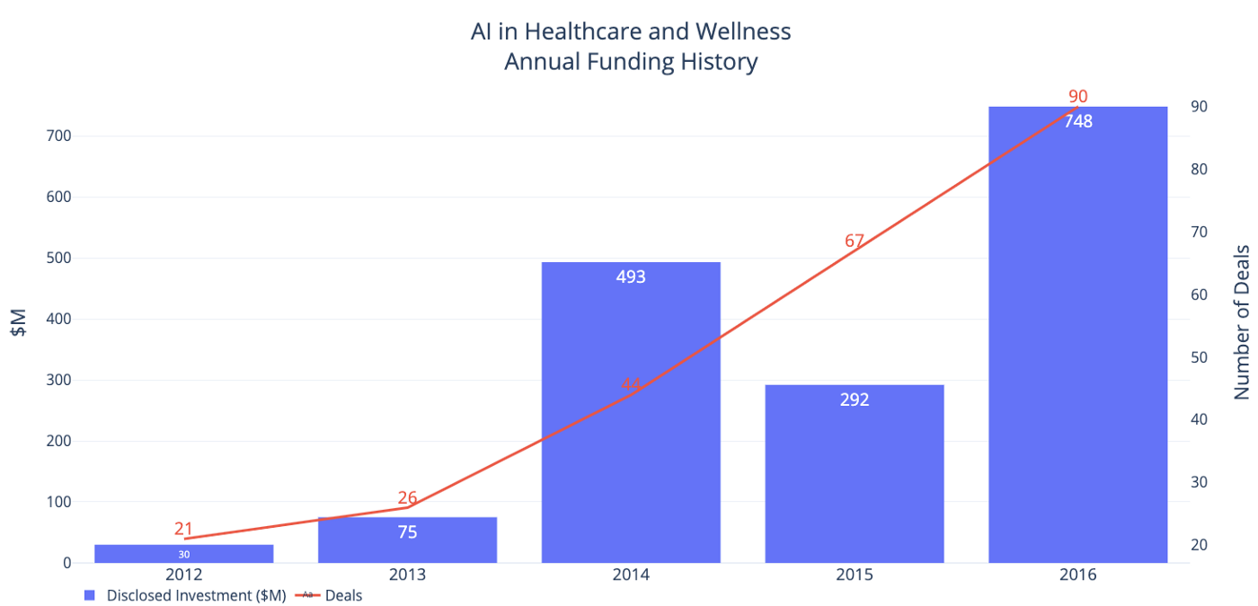

Source: [CB Insights](https://www.cbinsights.com/research/artificial-intelligence-healthcare-startups-investors/)

Artificial Intelligence is diffused in healthcare if we talk about the USA only then according to the reports, $2487.7 billion is alone invested in the USA to develop the healthcare sector [2]. This investment will have a huge impact on human wellbeing not only in the US but for every country. Similarly, the AI shortly will be advanced enough to detect diseases in patients at early stages, or based on the patient record, the AI-based system will tell us whether this patient will suffer from a specific disease or not. This way the doctors and nurses can cure patients more easily and in an effective way.

Artificial Intelligence trends are changing healthcare, we see advancement every day, some trends of AI are explained below.

# **Disease Prediction:**

We are living in the most advance and innovative era, disease prediction in a technique or a way to predict the disease in patients, plants, animals at early stages. This advancement is gradually improved with time. This era is using machine learning algorithms to diagnose the disease at early stages.

Disease prediction is done by using machine learning and deep learning techniques, these algorithms work on historical data. We feed historical data to the machine learning algorithms, based on the data, the model will predict whether the patient is having a specific disease or not. We are advancing enough to know if a person will have a specific disease shortly or not? This way we can take cures on time. These disease prediction models are also used in the agriculture sector, farmers lose their crops because of various plants and crop diseases, these diseases can be cured on time but if you don’t know that your plants and crops are suffering a disease then the results can be devastating.

To overcome this problem, many predictive models are deployed online where you can check whether your plant is having a disease. For example, potato leaves have two major diseases, early blight and late blight, different models are deployed online where a farmer inputs an image of potato leaf, the model will tell the farmer that either the plant is affected by early blight, late blight, or the plant is healthy.

Many companies these days are using predictive models to predict the disease at early stages. IBM is using a predictive model which is capable of telling whether the patient is having breast cancer or not. Advancements like this can help physicians to make decisions on time and do the best cure that was not possible some decades ago.

# **Telemedicine:**

The world is going towards Metaverse, shortly everything can be done online, shopping, watching movies, chatting, etc are the normal things that we do on daily basis. What if you do not go to the doctor and get your medical prescription at home? Well, this is possible, by using machine learning, many predictive models have been introduced in the market which will tell you which medicine to take if you are suffering a disease. This way the patients can receive the level of treatment without going to hospitals to see a doctor [2].

Different companies are working hard to introduce this telemedicine to the market, many companies have already done this, companies like Babylon Health have developed a mobile application based on artificial intelligence which will tell you which medicine to take. You will input your health condition to the application, the application will then tell you which medicine to take. This is called Triage in medical terminologies which is believed to be more accurate and effective than when performed by doctors and nurses.

Telemedicine is not based on AI-based chatbots, the real doctor is also monitoring the prescriptions, we cannot believe in predictive models because they are working based on a prediction, so these mobile applications and another online website that examines your current health and prescribe medicine are also monitored by doctors. These doctors are available online 24/7 to monitor a patient on a remote basis. They will conduct an interview of your physical health by video streaming.

# **Robotic Surgeries:**

The advancement in healthcare is unstoppable, robotic surgeries are being performed on daily basis nowadays. In recent years, the investment in robotic surgeries get in billions, experts said that robotic surgeries are the future of manual surgeries. The market cap for robotic surgeries is currently $4 billion [3]. This cap is still smaller than the market cap of the traditional surgeries market cap.

Now the question is how do these surgical robots work? The answer is Artificial Intelligence, as we mentioned above that the machine learning algorithms work on historical data, similarly, these surgical robots also perform surgeries based on the historical data that we feed to the machine. We train the robot on the data to perform well and accurately.

According to Mayo Clinic, these surgeries are not that complicated as compared to manual traditional surgeries, the time of recovery is good enough and minimal scarring than manual surgeries [4]. According to World Health Organization (WHO), by 2030, the medical professional shortfall will be 10 million, this is a serious thing to worry about, in such a scary situation only robotic surgeons can save us.

A company named Intuitive Surgical Inc., has designed an AI surgical robot, they named it the da Vinci surgical system, this AI-based surgical robot is trained on a huge number of data, the baseline recognition accuracy is said to be 25% accurate [5]. In my point of view, this accuracy is not good hence I will personally not allow a machine having a 25% accuracy rate to operate me but shortly we will increase the accuracy.

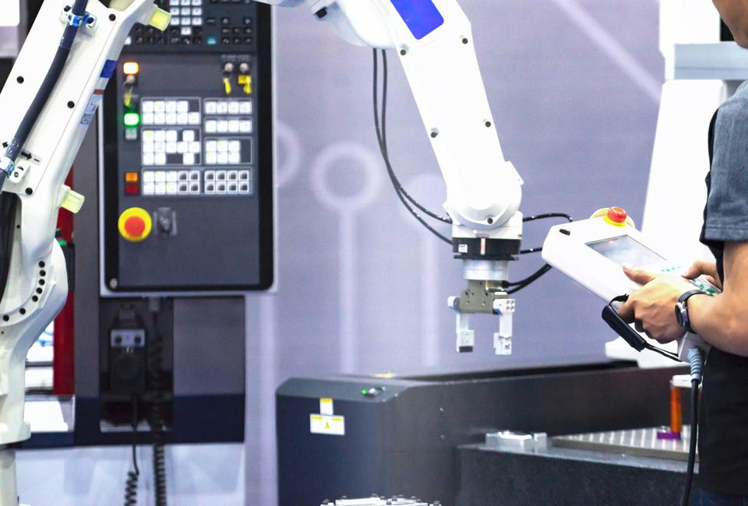

# **Wearables And Personal Devices:**

We have moved so far that we do not need to stay at hospitals for our daily checkups, we are advanced enough that we have invented wearables that track our health condition in real-time. Smart wearables are devices such as FitBits and smartwatches which are designed to collect data of a person mental and physical health, these devices are used to track your exercise records and count your daily calories consumptions, make diet plans for you based on your current health condition tracked by the smart device, these devices send the data to your doctor on a real-time basis, in case if you are serious your doctor can take immediate actions to prevent any further damage to your good health.

The demand for these smart wearable devices is going higher and higher day by day and shortly, these devices will conquer the world, it is good for us to use these smart devices because we have many other important works to do, these devices will track our health condition.

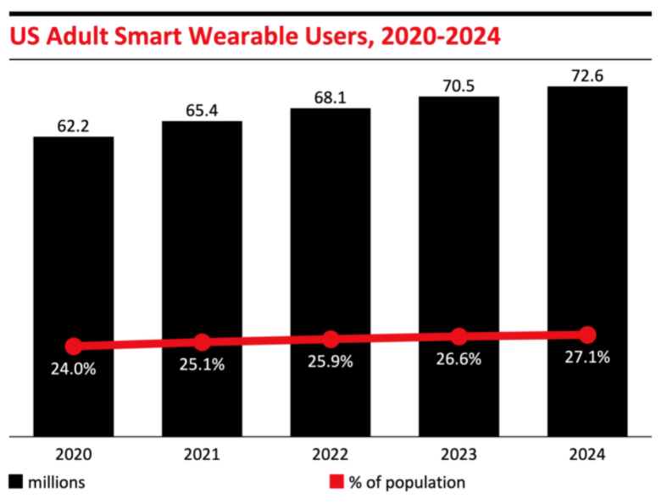

Source: [INSIDER](https://www.businessinsider.com/wearable-technology-healthcare-medical-devices)

According to a survey, more than 80% of consumers want to wear these smart healthcare devices [6]. Alone in the US, 25.1% of the whole population of adults are wearing these smart devices in 2021, in 2024 27.1% population will use these devices to take advantage of them. This growing market and usage of these devices are revolutionizing the market and many innovative companies are now working to produce more of it. Shortly, the demand will touch the sky.

The most used wearable devices are wearable fitness trackers, this device is used to track our daily exercise records, these are wristbands smart devices with sensors that track our routine exercise and heartbeat rate. Smartwatches are now introduced in the market which is used to take care of our health, Apple launched its first smart healthcare watch in 2017 to monitor the health condition of its wearer. Blood pressure monitors and Biosensors are introduced in the market.

# **Healthcare administration and management:**

Healthcare administration and management are two different things but the functionalities are the same, healthcare management is the management of the whole hospital, which includes proper treatments, scheduling appointments, appointing doctors, etc and healthcare administration focuses on individual departments and their budgets.

These days, much artificial intelligence software is used by different healthcare centers to handle everything on its own and quickly. This AI-based management software is used to help clinics and hospitals to run all their major task through it. These include paying bills, checking for patient insurance, payrolls, accounting, medical report, etc efficiently and quickly.

# **Cancer detection and treatment through AI:**

Artificial Intelligence is growing in the healthcare field, researchers are working hard day and night to make healthcare more innovative and advanced. Besides all the other tools and wearables that are taking care of our health, researchers have introduced a new way to detect cancer by using a high level of artificial intelligence [7].

According to National Cancer Institute, AI, machine learning, and deep learning can all be used to detect cancer in a patient at early stages [8]. When cancer is detected at an early stage, its treatment becomes easy. Artificial intelligence is helping doctors and physicians to detect cancer easily and quickly. This method is more reliable, cheap, accurate, and quick.

“Integration of AI technology in cancer care could improve the accuracy and speed of diagnosis, aid clinical decision-making, and lead to better health outcomes. AI-guided clinical care has the potential to play an important role in reducing health disparities, particularly in low-resource settings,” [NCI wrote on Cancer Detection & Diagnosis Research.](https://www.cancer.gov/research/areas/diagnosis/artificial-intelligence)

Researchers have collected big data of different cancers patients all over the world, they used this data to train a model. This model will do the cancer prediction based on the historical data of different cancer patients. When you input an image of blood cells, tissues, and tumors, the model will tell you whether the patient is having cancer or not with accurate precision. These models are smart enough to tell you the stages of cancer too.

# **Detection of mycobacterium tuberculosis using artificial intelligence:**

Researchers also worked on detecting mycobacterium tuberculosis by using artificial intelligence, according to a research paper, they detected this disease with 97.94% precision [9]. This accuracy is outstanding and cannot be denied.

TB is one of the main issues worldwide that is seriously dangerous for public health, through the use of pathology, we detect TB, but we are now living in an advanced era so we have built predictive models which predict TB in a patient. The method that the researcher used for this purpose is the same as they used for cancer detection, image classification is one of the techniques which tells us whether the patient has TB or not.

# **Mental illness:**

As long as physical is important, mental health is also important. Researchers these days are working to cure mental health by using Artificial Intelligence. Researchers from MIT and Harvard Institute gathered messages online and used natural language processing (NLP) techniques to know if a person is having suicidal thoughts or not. Due to the pandemic, people suffered loneliness at an extreme level, financial problems, social problems, etc, were analyzed by the researchers to bring useful insights.

Detecting whether the patient is having depression or not is done by the use of artificial intelligence and machine learning, the patient's speech and facial recognition will be noticed by the trained model, the AI-based model will evaluate the patient expressions and speech and will finalize the results [10].

Similarly, other tools are also being in use which tracks our location and our texting, etc, these tools analyze everything and if you find something wrong with your daily routine, it will warn you immediately. This is how artificial intelligence is changing the world.

# **Natural Language Processing (NLP):**

Natural language processing is the subset of machine learning and artificial intelligence which is used to analyze human languages, NLP is the interaction between computers and human languages, NLP algorithms are smart enough to know what a human is saying based on his/her speech. In healthcare, many innovations have smartened the healthcare sector which includes natural language processing too. Many practitioners are using these NLP techniques to deal with a massive number of unstructured data to provide the best services to the patients on time.

According to research, natural language processing is going to hit $3.7 billion by 2025 with an annual growth of 20.5% [11]. This is a huge amount that will be invested in healthcare to innovate the NLP more.

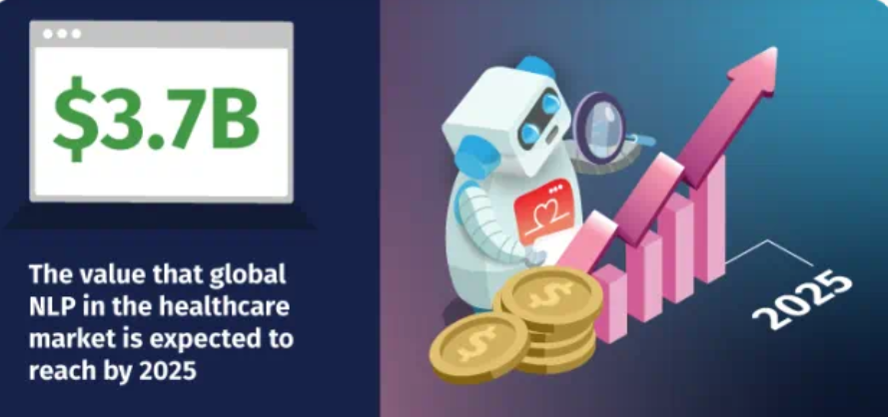

The use of NLP in healthcare is limitless, natural language processing is used in hospitals and clinics to review the complex EHR reports rather than checking the patient's reports manually, NLP analyzes every report quickly and correctly, hence time is saved, and curing becomes fast and quickly. NLP also helps to keep the patient records safe and up to date.

We used to store patient records manually that is on paper, by using the NLP, we have to first digitalize all the paperwork of all the patients, after that we can apply natural language processing on it. The NLP will analyze the clinical reports of each patient and will tell us whether the patient is having some serious issues during his/her treatment or not.

Apart from all this, many companies have developed intelligent mobile and desktop applications which recognize the texts we enter, for example, if I enter that I am having a headache, the application will understand my language and will guide me on what to do to cure myself on my own. Similarly, many other smart applications track our messaging and texts, these applications analyze the texts, and based on what we send to each other the application will know how do you feel, if the application detects any serious issue in your texts, it will immediately inform you about that.

# **Future of AI in healthcare:**

The future of AI is clear just like crystal-clear glass. We are stepping slowly and gradually into a very innovative world, a day is not so far that you will not need any hospitals and doctors anymore, you will be examined by smart machines and smart wearables. In case you need a doctor, you can consult the doctor remotely, because the world is going towards Metaverse where everything will be online, stores, markets, properties, clinics, etc will be online. We will live in an imaginary world and that is true.

# References

|  |  |
| --- | --- |
| [1] | V. A. Buch, "Artificial intelligence in medicine: current trends and future possibilities," 2018. |
| [2] | E. Zuccarelli, "3 AI Trends That Will Revolutionise Healthcare," 2020. |
| [3] | W. Gonzalez, "How AI Trends Could Transform The Healthcare Industry," 2021. |
| [4] | M. Clinic, "Robotic surgery," 2020. |
| [5] | B. T. L. A. M. J. S. R. George EI, "Origins of Robotic Surgery: From Skepticism to Standard of Care," 2018. |
| [6] | A. Phaneuf, "Latest trends in medical monitoring devices and wearable health technology," 2021. |
| [7] | M. Erin McNemar, "Top Opportunities for Artificial Intelligence to Improve Cancer Care," 2020. |
| [8] | N. C. Institute, "Artificial Intelligence - Opportunities in Cancer Research," 2020. |
| [9] | X. B. A. H. K. Z. L. C. Yan Xiong, "Automatic detection of mycobacterium tuberculosis using artificial intelligence," 2018. |
| [10] | A. Ansari, "Five Ways AI Can Help Revolutionize Mental Healthcare," 2020. |
| [11] | A. Leigh, "6 Uses for Natural Language Processing in Healthcare," 2021. |